# Experiment No: 8

# Title: Development of different timer Applications.

**Date: /12/2021**

**Name: Shaunak Deshpande**

**Class: TY IC-C**

**Roll number: 39**

**GR Number: 11911180**

1. **Implement TON, TOF and TP timer.**

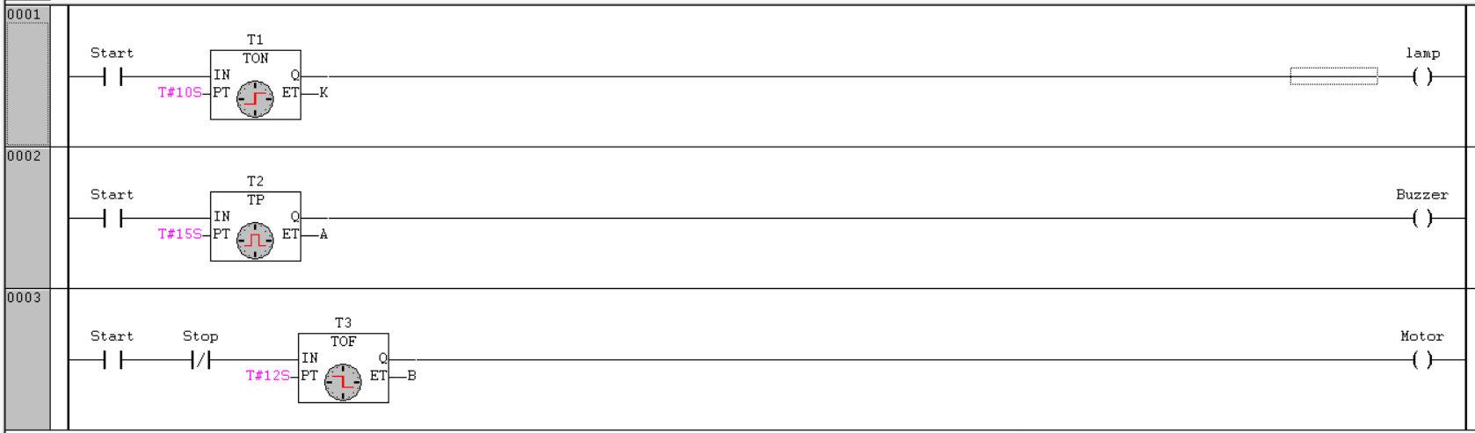

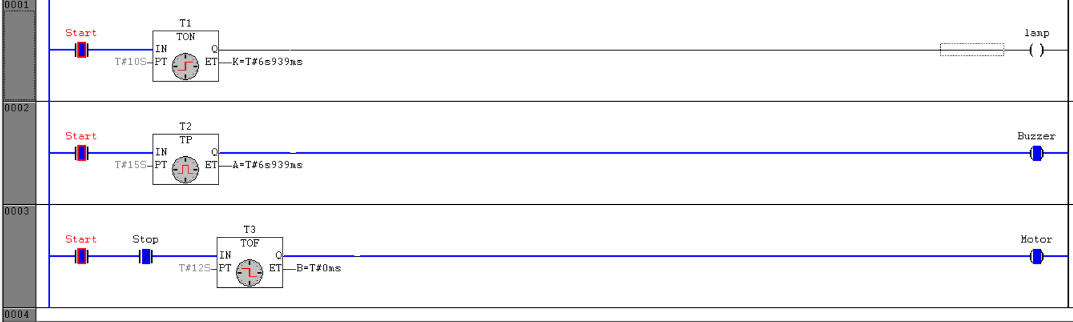

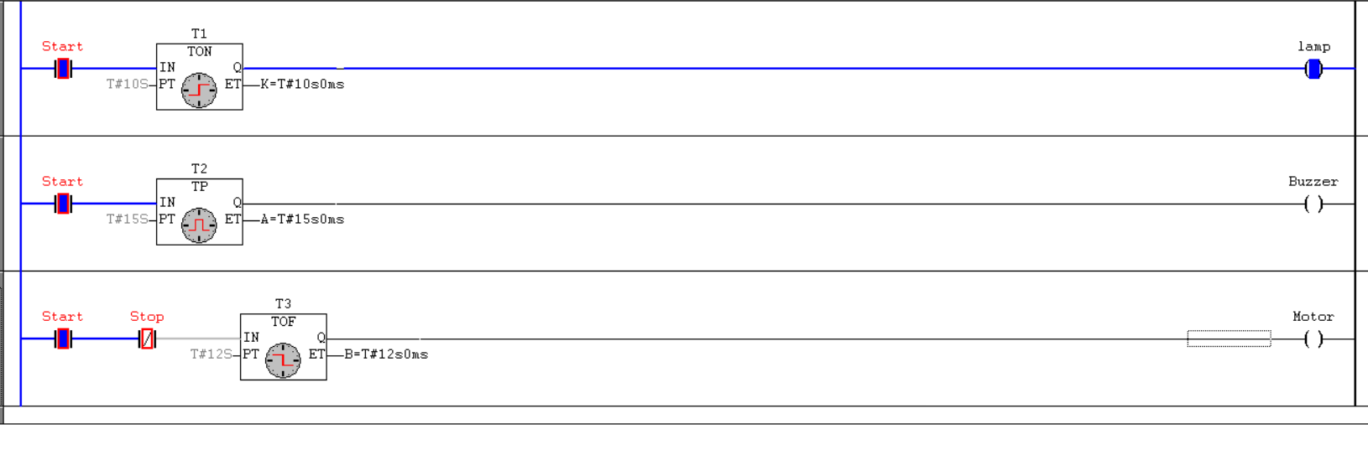

1. **Cascading Motors-**

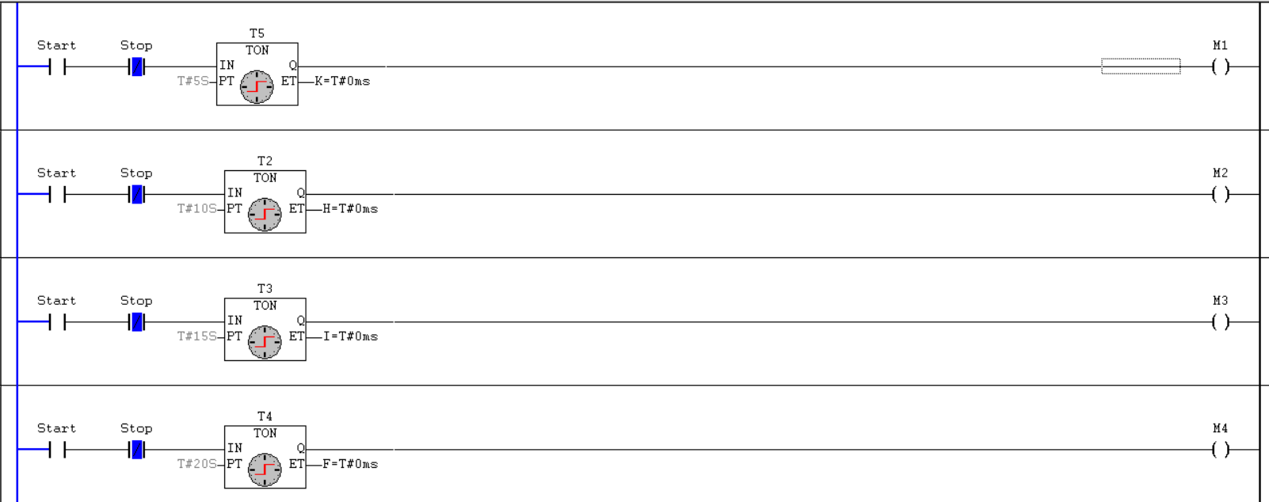

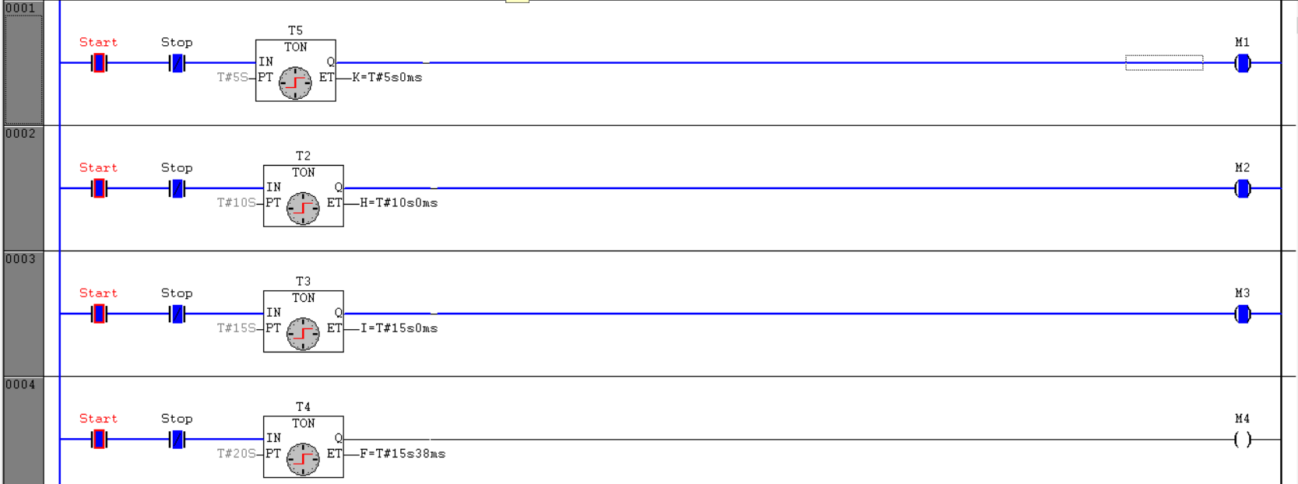

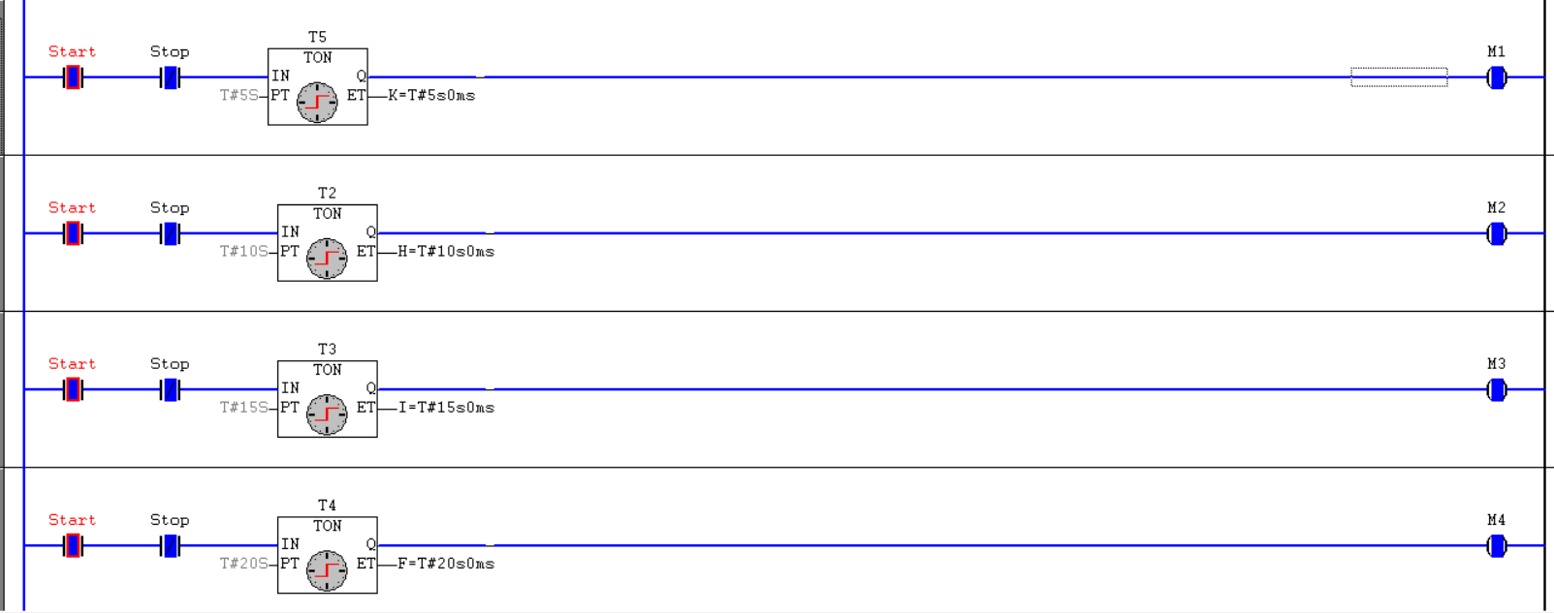

1. **There are 4 outputs R, S, T, U. R starts immediately when input is activated. S starts 4 seconds later; T starts 10 seconds later than S and U goes on 20 seconds after S. When stop switch is pressed all outputs are off.**

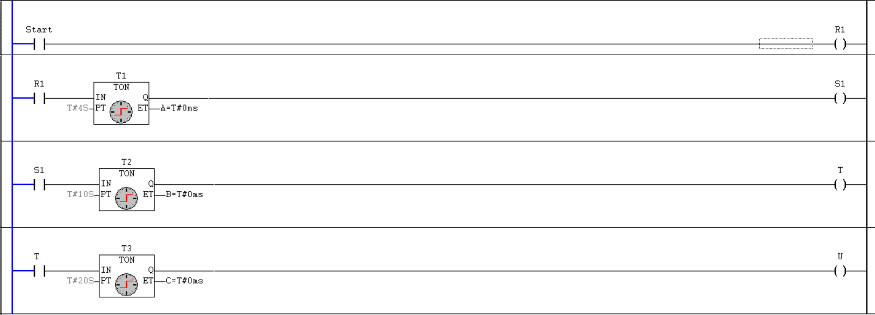

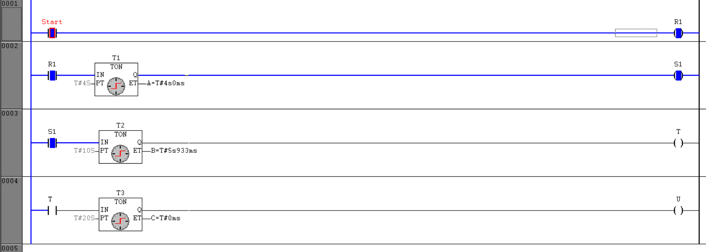

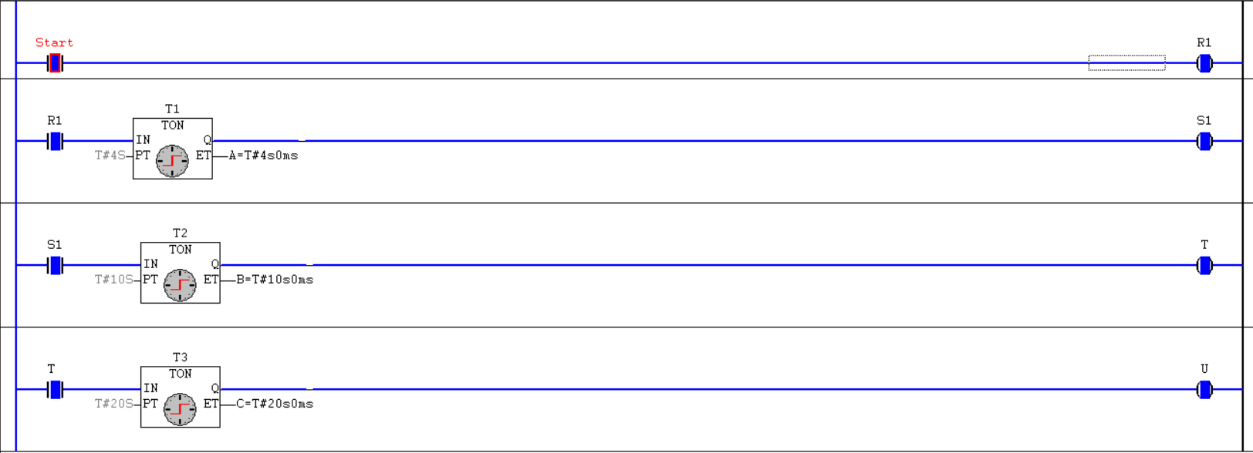

1. **E and F are turned on by a switch. When the switch is turned off E goes off immediately. F remains on for another 10 seconds and then goes off.**

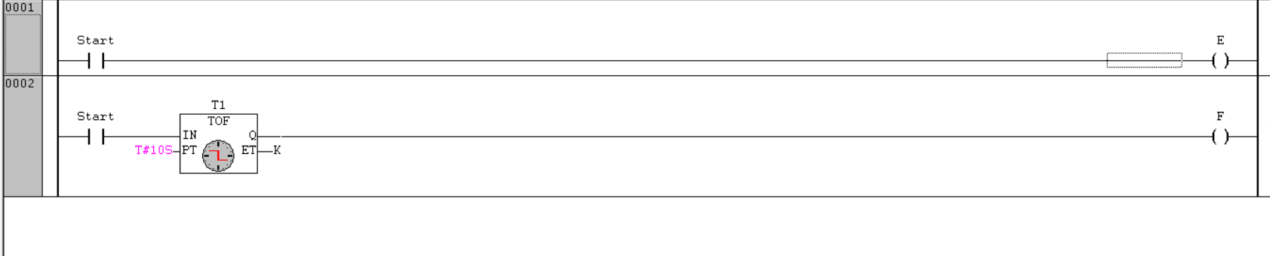

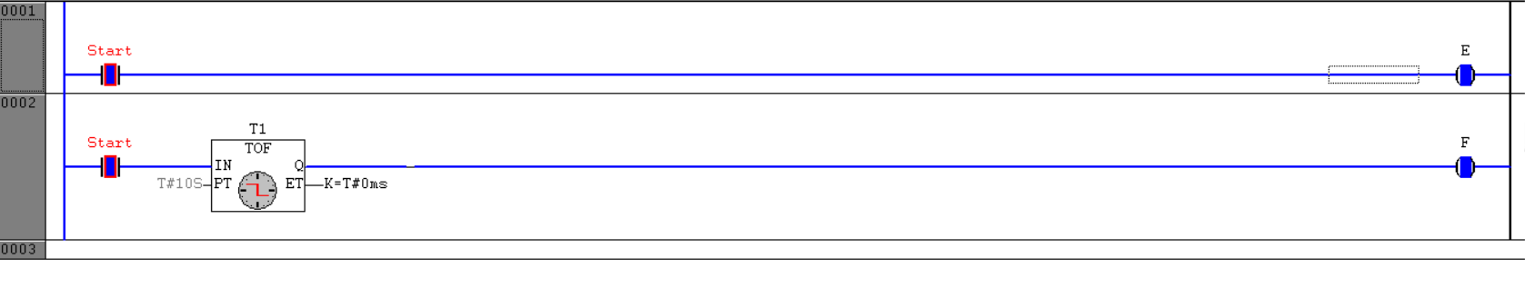

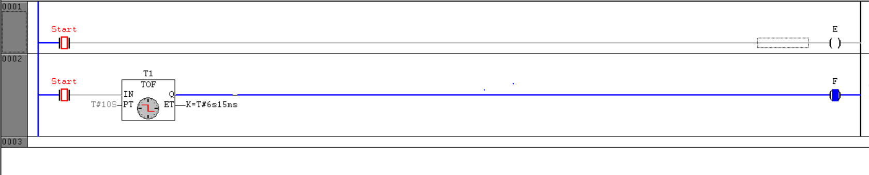

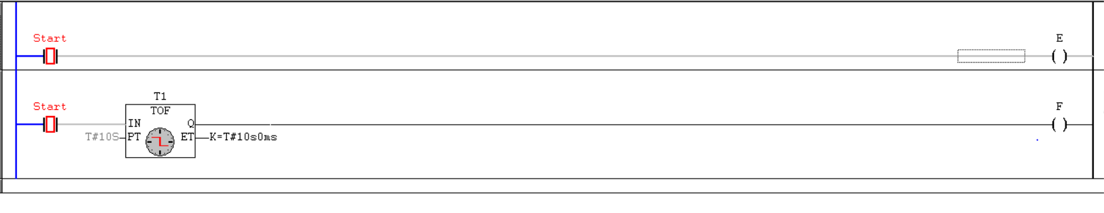

1. **When a start button is pressed, motor M1 is started. After 5 sec motor M1 stops and M2 starts. After 5 sec motor M2 starts and motor M3 starts.**

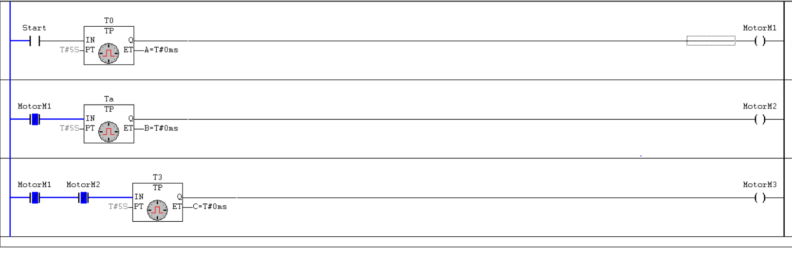

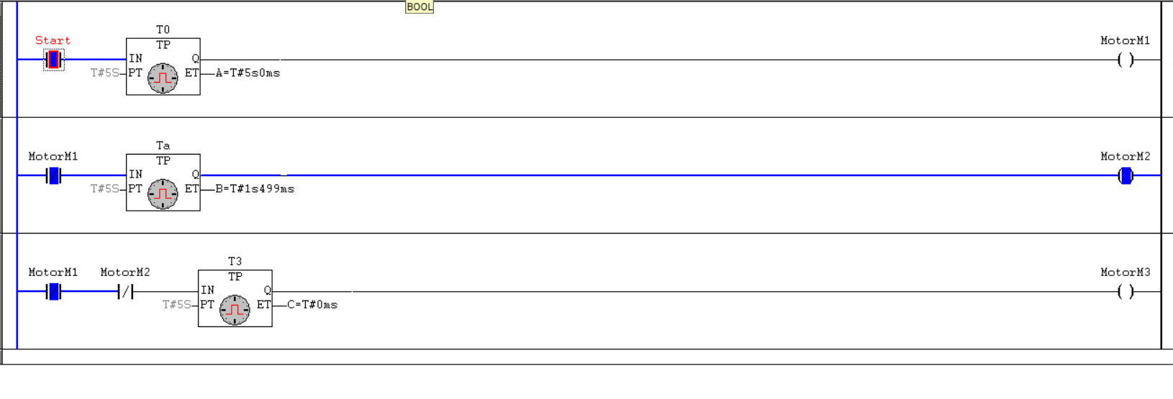

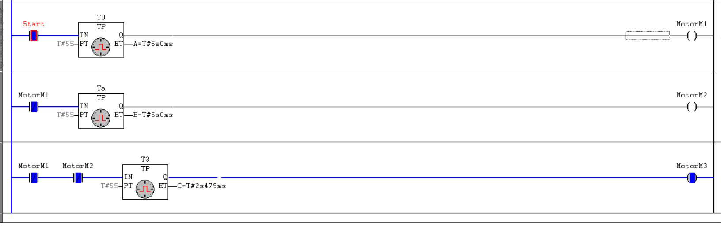

1. **When start button is on, start heater H1, H2 and H3 immediately. When stop button is on H1 is off immediately then H2 is off after 10 seconds and H3 is off after 20 seconds.**

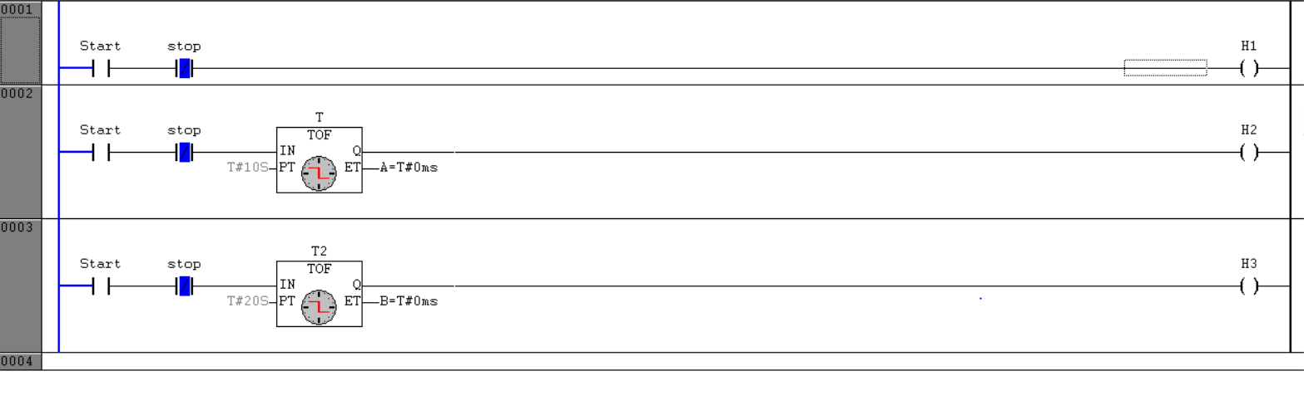

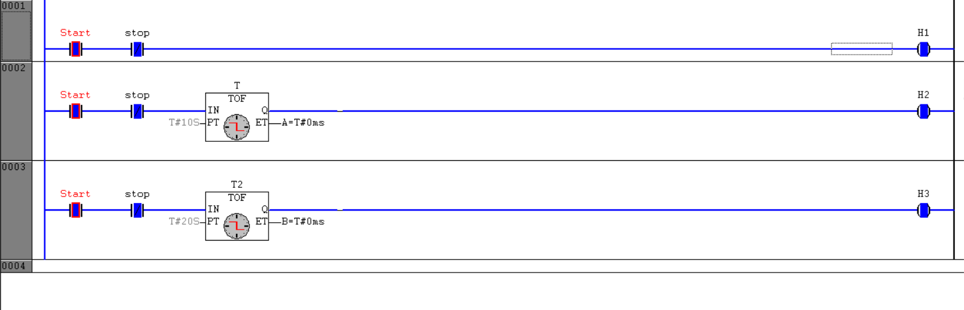

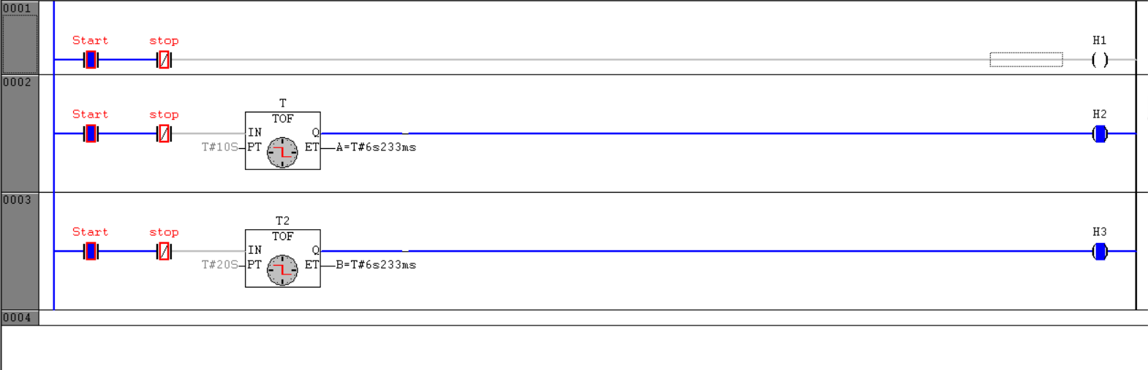

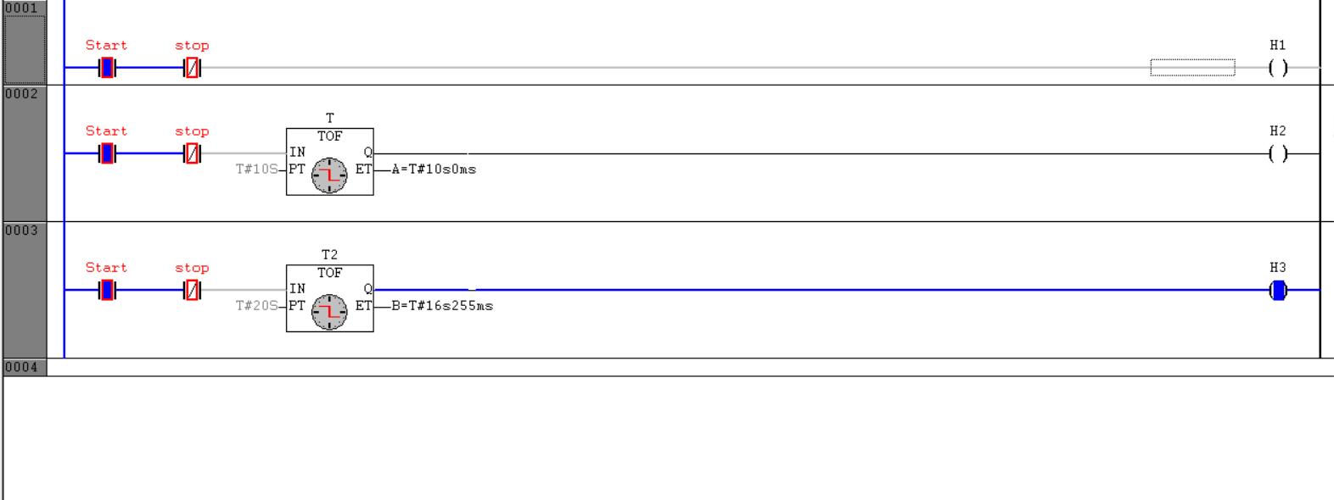

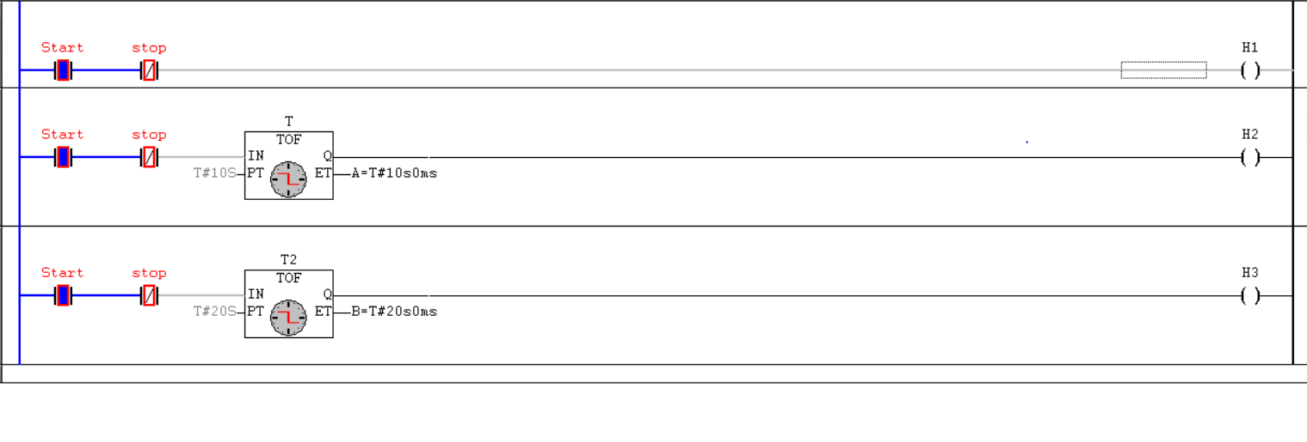

**Conclusion-**

Timer applications such as TON, TOF, TP, cascading of motors, on and off of heaters have been implemented and simulated in CoDeSys software.